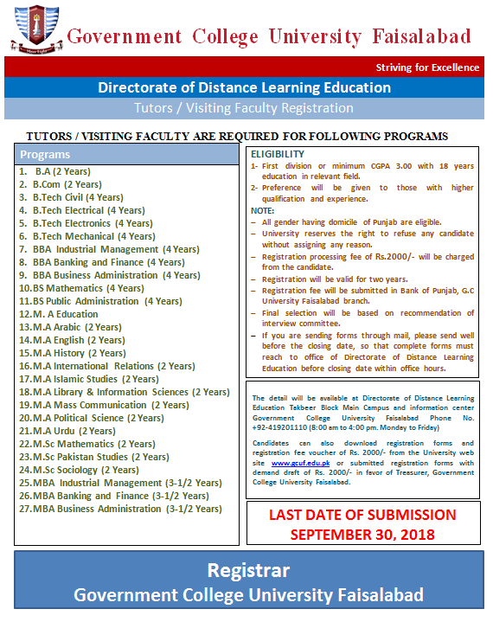
 | Government College University, Faisalabad  Directorate of Distance Learning Education  Tel: 041-9201110  TUTOR / VISITING FACULTY REGISTRATION FORM
1. Tutor / Visiting faculty applying for a program:
_________________________________________________
_________________________________________________
2. Full name(in Block letters):
_________________________________________________
_________________________________________________
3. Father’s name:
_________________________________________________
_________________________________________________
4. (i) Correspondence address:
(ii) Mobile: _____________________________________ Landline ________________________
(iii) E-mail:______________________________________________________________________

(iv) Permanent address: ___________________________________________________________
5. Date of birth (Age (years-months-days) at the time of closing date must be mentioned):

6. Nationality of:
(a) Self ___________________________

(b) Spouse_________________________
7. National Identity Card No:

________________________________________________________
8. (a) Educational qualifications:
Certificate /Degree obtained | Institution attended | Year attended |  | Division/  CGPA | Marks obtained/Total Marks | Major subjects
Certificate /Degree obtained | Institution attended | From | To | Division/  CGPA | Marks obtained/Total Marks | Major subjects
Matric or equivalent | BISE_____
Intermediate or equivalent | BISE_____
Bachelor’s degree or equivalent
Master’s degree or equivalent
M. Phil. /MS or equivalent
Ph. D.
Any other qualification

(b) Professional qualifications /trainings :
Name & place of Institution | Certificate /  Diploma obtained | Year attended |  | Major subjects
Name & place of Institution | Certificate /  Diploma obtained | From | To | Major subjects

(c) Academic distinction(s):
(d) Distinction(s) in Sports and other co-curricular activities:
9. Research work and publications:
Give details of all research publications and presentations including name of Journals etc. List to be attached (use extra page, if required)
10. Language Proficiency (Good, Average, Fair):

Language | Reading | Writing | Speaking

11. Employment record and experience (clearly filled):
Post Held | Institution / Organization | Duration |  | Total Experience
Post Held | Institution / Organization | From | To | Years | Month | date
TOTAL EXPERIENCE

12. Membership/ Fellowship of professional bodies: (Give the name(s) and nature of membership(s) or office(s) held)

13. Foreign visit(s):

Country | Duration |  | Purpose of visit(s)
Country | from | to | Purpose of visit(s)

14. Are you suffering from any physical disability? Yes / No
15. Have you ever been convicted from any court of law, (if yes, give details).
16. Have you obtained permission from your present employer to apply for this post:
17. Give names and addresses of at least two referees:
(1) ________________________________ |  |  |  | (2) __________________________________
________________________________ |  |  |  | __________________________________
18. List all the documents attached with Application Form.
(i) |  | (vi) |  |  |  | (xi)
(ii) |  | (vii) |  |  |  | (xii)
(iii) |  | (viii) |  |  |  | (xiii)
(iv) |  | (ix) |  |  |  | (xiv)
(v) |  | (x) |  |  |  | (xv)

19. Please attach herewith a brief resume of your academic / professional achievements, on extra sheet, not exceeding 300 words

DECLARATION

I, hereby solemnly declare that documents / testimonials / degrees / diplomas / experience certificates attached alongwith are valid and true to the best of my knowledge and belief. Moreover, I will be responsible if any information proved otherwise.

Date: _______________ Signature of the applicant: ___________________

INSTRUCTIONS

- This form must be accompanied by:
(a) Attested copies of all the relevant certificates and testimonials.
(b) Three (02), Recent passport size photographs for all the posts.
- Those already in service should submit applications Through Proper Channel, by the due date.
- The University reserves the right not to fill any vacancy or vary the number of positions, without assigning any reason or consider for appointment on any other position.
- The applications complete in all respect should be submitted as under:
- Tutors/Visiting Faculty Two Copies
- Additional sheets may be attached where space in columns is insufficient.

Signature of the applicant: __________________

